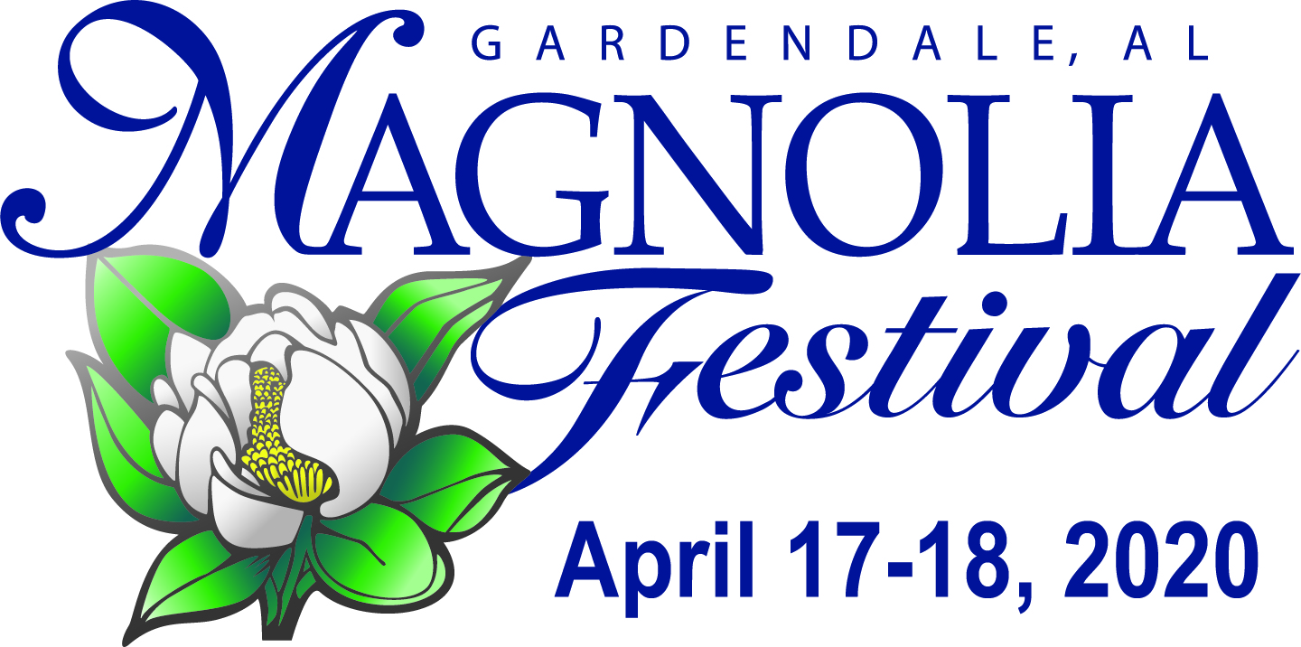
Sponsorship Opportunities

Please review the following sponsorship benefit packages and select the one that best suits your needs. If you choose a package that includes your logo on signage, please email your color AND black and white logo to: gdalemagfest@gmail.com. For questions, call or text Kathleen Phillips at 205-913-0538.
MagnoliaFestival.org

Presenting Sponsor – City of Gardendale

Diamond Level $7,500+ (Deadline January30, 2020)
*Logo on television advertisements.
*Logo on highway billboard.
*Logo on The North Jefferson News ad, festival website, posters, flyers, and t-shirts.
*Logo post of your sponsorship on Magnolia Festival Facebook page (6.5K Followers) and Instagram
*Logo on both live entertainment stage banners.
*Logo on MagnoliaFestival.org website listed after Presenting sponsor.
*Special recognition plaque for festival support.
*Corner/end vendor booth space, if desired.
*12 free festival t-shirts, if desired. (Can be given away as promotion.)
* Receive an “Event Sponsor” yard sign to display in window or yard & at festival booth, if desired.
* Email to chamber members from Gardendale Chamber of Commerce listing all sponsors.

Platinum Level $5,000+ (Deadline-February 12, 2020)
*Logo on highway billboard.
*Logo on The North Jefferson News ad, festival website, posters, flyers, and t-shirts.
*Logo post of your sponsorship on Magnolia Festival Facebook page (6.5K Followers) and Instagram
*Logo on both live entertainment stage banners.
*Logo on MagnoliaFestival.org website listed after Diamond sponsor.
*Special recognition plaque for festival support.
*Corner/end vendor booth space, if desired.
*8 free festival t-shirts, if desired. (Can be given away as promotion.)
* Receive an “Event Sponsor” yard sign to display in window or yard & at festival booth, if desired.
* Email to chamber members from Gardendale Chamber of Commerce listing all sponsors.

Gold Level $2,500+ (Deadline-February 12, 2020)
*Logo on The North Jefferson News ad, festival website, posters, flyers, and t-shirts.
*Logo post of your sponsorship on Magnolia Festival Facebook page (6.5K Followers) and Instagram
*Logo on both live entertainment stage banners.
*Logo on MagnoliaFestival.org website listed after Platinum sponsor larger than Silver Level.
*Special recognition plaque for festival support.
*Corner/end vendor booth space, if desired.
*6 free festival t-shirts, if desired. (Can be given away as promotion.)
* Receive an “Event Sponsor” yard sign to display in window or yard & at festival booth, if desired.
* Email to chamber members from Gardendale Chamber of Commerce listing all sponsors.

Silver Level $1,000+ (Deadline-March 3, 2020)

*Logo on The North Jefferson News ad, festival website, posters, flyers, and t-shirts.
*Logo post of your sponsorship on Magnolia Festival Facebook page (6.5K Followers) and Instagram
*Logo on both live entertainment stage banners.
*Logo on MagnoliaFestival.org website listed after Gold sponsor larger than Bronze.
*Framed certificate of support
*Free aisle vendor booth space, if desired.
*5 free festival t-shirts, if desired. (Can be given away as promotion.)
* Receive an “Event Sponsor” yard sign to display in window or yard & at festival booth, if desired.
* Email to chamber members from Gardendale Chamber of Commerce listing all sponsors.

Bronze Level $500+ (Deadline-March 3, 2020)
*Logo on The North Jefferson News ad, festival website, posters, flyers, and t-shirts.
*Logo post of your sponsorship on Magnolia Festival Facebook page (6.5K Followers)
*Logo on both live entertainment stage banners.
*Logo on MagnoliaFestival.org website listed after Silver sponsor.
*Unframed certificate of support
*Free aisle vendor booth space, if desired.
*3 free festival t-shirts, if desired. (Can be given away as promotion.)
* Receive an “Event Sponsor” yard sign to display in window or yard & at festival booth, if desired.
* Email to chamber members from Gardendale Chamber of Commerce listing all sponsors.

Supporter Level $250+ (Deadline-March 3, 2020)
*Company NAME ONLY-Not LOGO included on festival website, t shirts and flyers
*Company NAME ONLY-Not LOGO on both live entertainment stage banners.
*2 free festival t-shirts, if desired. (Can be given away as promotion.)
* Email to chamber members from Gardendale Chamber of Commerce listing all sponsors.

