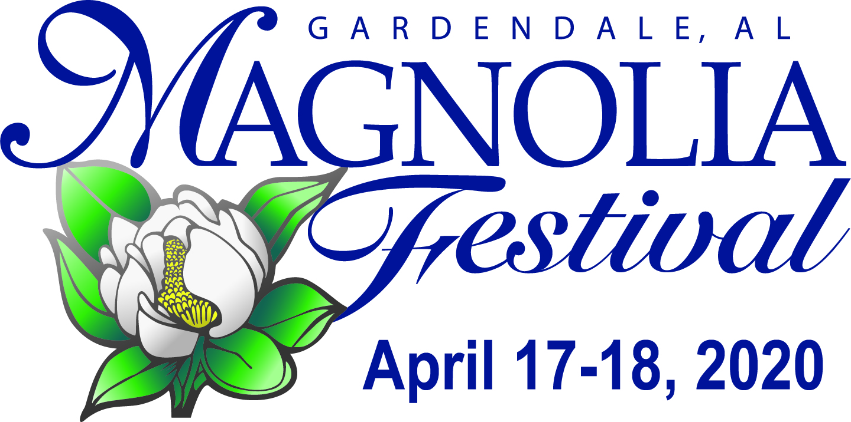

www.magnoliafestival.org

Gardendale Civic Center Complex * 857 Main St, Gardendale
Friday 5pm-10:00 pm, Saturday 10am-5pm

2020 FOOD VENDOR APPLICATION
Late fee $10.00 received after Feb 27 - If space still available.

Please read the Food Vendor Terms and Conditions before filling out application.

BUSINESS NAME:___________________________________________________________________________

CONTACT PERSON:_________________________________________________________________________

MAILING ADDRESS:_________________________________________________________________________

EMAIL ADDRESS:(required)___________________________________________________________________

CITY, STATE, & ZIP_________________________________ PHONE: ( ) _________________________

Email Kathleen at gdalemagfest@gmail.com with questions.

Friday Night (5-10:00pm) 12’ x 10’ space = $175 ____________
Additional booth space + = $100 _______________
Electricity
120V, 20Amp connection $35 _____________
240V, 50Amp connection $50 _____________
(Must email pic of exact amp plug using)

Saturday (10am-5pm) 12’ x 10’ space = $175 ____________
Additional booth space + = $100 _______________
Electricity
120V, 20Amp connection $35 _____________
240V, 50Amp connection $50 _____________
(Must email pic of exact amp plug using)

No continuous water flow available. Buckets of water available at water fountain spigot to carry back for hand washing.

Total Fees Total $____________

Note: Electricity is $35/$50 per day/per vendor.

*Vendor must supply own heavy-duty electrical extension cord of at least 100’.
*Generators will be allowed if silent.
*Large bags of ice are sold 2 minutes from venue at The Ice Hole in front of America’s Thrift Store, 1315 Decatur Hwy, Gardendale.
*Gardendale Magnolia Festival has the right to refuse any vendor or product that is in conflict with festival or community standards.

Picture of operation has been emailed (if new vendor for festival) ______ (check mark)
I understand menu signage with prices must be displayed and in large lettering_________(initials)

Make checks payable to Gardendale Magnolia Festival and mail to:
Gardendale Magnolia Festival, P.O. Box 445, Gardendale, AL 35071

Do not write in space below:

________ Date received ______Health Dept. form attached ______ Waiver/Release attached

_____Picture attached or emailed ________check number _________confirmation sent

