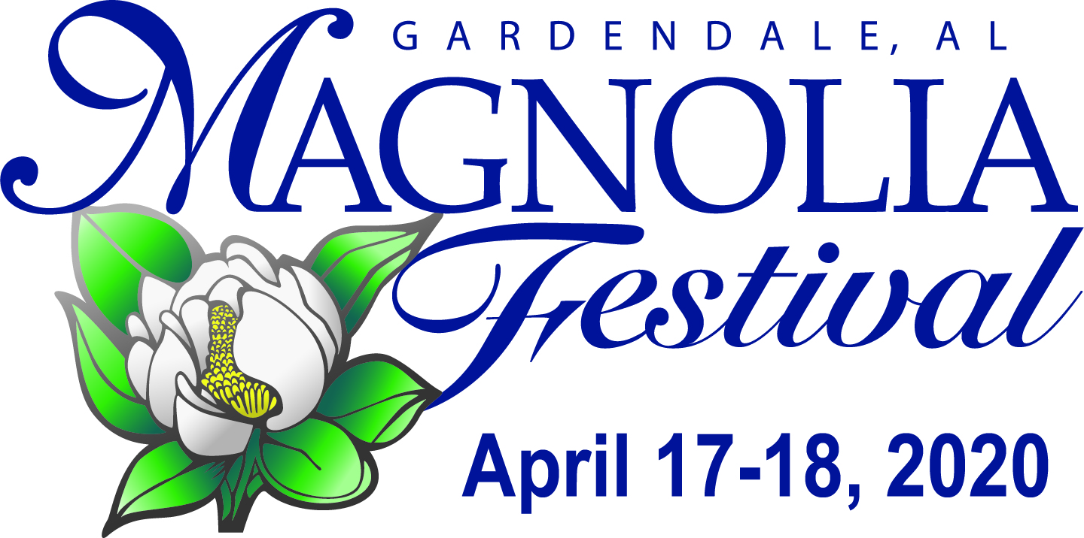

Gardendale Civic Center, 875 Main St.
April 17 (5pm-10pm) & April 18, 2020 (10 am–5 pm)

Arts/Crafts/Business Vendor Booth Application

VENDOR BOOTHS WILL BE SATURDAY APRIL 18th ONLY.
Friday Night: Limited food vendors, one stage live entertainment, and midway carnival. Saturday: 3 stages of live entertainment and full schedule of events including arts/craft/business vendors (No vendors on Friday). REGISTRATION: FRIDAY 4/17 9-5:30 PM AND SATURDAY 4/18 6-8 AM

DEADLINE April 3, 2020

Company/Organization Name:_______________________________________________________________________
Applicant(s) Name:_____________________________________________________________
Address:_____________________________________________________________________
City:____________________________________ State________________ Zip_____________
E-mail _____________________________________________________________________
Phone _______________________________________________
(Vendor information will not be sold or distributed to any third parties. Phone numbers are for festival
Organizers only in the event of festival changes or if additional information is needed.)

Please list the item(s) you wish to exhibit or give away at the Gardendale Magnolia Festival in the space provided below: (REQUIRED)

__________________________________________________________________________________________________________________________________________________________Vendors may not give away bottled water or food items other than candy.

I am a RETURNING VENDOR ______YES ______NO
*New vendors must provide pictures of their items/booth setup.
ALL BOOTHS SUBJECT TO REVIEW BEFORE APPROVAL

PLEASE CHOOSE YOUR SPACE BELOW:
All Exhibit Spaces are 10'x10'

INSIDE: Civic Center: (first come first served-limited)
QTY $ AMOUNT
________Aisle Booth(s) $60.00…………………………………………………………………………………………..…………_____________
________Corner Booth $100.00……………………………….…………………………………………………………………..._____________
________Non-Profit Aisle $30.00(Limited spaces available)………………………………………..….…….._____________
________Electrical Connection 120V, 20Amp connection $20(You must provide cord)…._________
________ Electrical Connection 240V, 50Amp connection $35(You must provide cord)….________
________Late Fee (if postmarked after 4/6/20) $10.00……………...…………………………………………… _______________

OUTSIDE: Civic Center Complex Grass:
QTY $ AMOUNT
________Aisle Booth(s) $60.00…………………………………………………………………………………………..…………_____________
________Corner Booth $100.00……………………………….…………………………………………………………………..._____________
________Non-Profit Aisle $30.00(Limited spaces available)………………………………………..….…….._____________
________ Electrical Connection 120V, 20Amp connection $25(You must provide cord)…._________
________ Electrical Connection 240V, 50Amp connection $50(You must provide cord)….________
________Late Fee (if postmarked after 4/3/29) $10.00……………...…………………………………………… _______________
OUTSIDE: Street Level/GFBC Lot:
QTY $ AMOUNT
________Aisle Booth(s) $60.00…………………………………………………………………………………………..…………_____________
________Corner Booth $100.00……………………………….…………………………………………………………………..._____________
________Non-Profit Aisle $30.00(Limited spaces available)………………………………………..….…….._____________
________ Electrical Connection 120V, 20Amp connection $25(You must provide cord)…._________
________ Electrical Connection 240V, 50Amp connection $50(You must provide cord)….________
________Late Fee (if postmarked after 4/3/20) $10.00……………...…………………………………………… _______________
Total Number of booths and amount: $__________
(Vendors need to provide their own racks/shelving/lattice work, etc to hang items and separate their booth from the others, if desired. No pipe and draping will be provided. You must provide your own tables/chairs. Nothing can be hung/taped to the wall. 10 x 10 spaces will be taped off.)

(ALL EXTENSION CORDS MUST BE AT LEAST 100 FT LONG)
(Vendor to furnish own heavy-duty extensions.)

Tourism Data:
I will be driving from ____________________________Town _______State.
I plan to stay over ____Fri ______Sat night.
I will be staying in ____Gardendale hotel ______Fultondale hotel ____RV ______Other
_____I am within driving distance and will drive back and forth.

Fill out and return WITH WAIVER to: Gardendale Magnolia Festival, Attention: Amee Donald,
PO BOX 445 Gardendale, AL 35071,
Questions: (205) 585-3915 NO HAND DELIVERED APPLICATIONS WILL BE ACCEPTED

Acceptance of Rules:
I/we the applicant(s) have read the "2020 Terms & Conditions" and "RELEASE and WAIVER of LIABILITY and INDEMNITY AGREEMENT" listed separately and agree to abide by said conditions.

Exhibitor’s Signature_______________________________________________Date_________
________________________________ ______________

For Internal Use Only
 Accept: __________Date ____________Check # _____________$ Paid _____Decline

